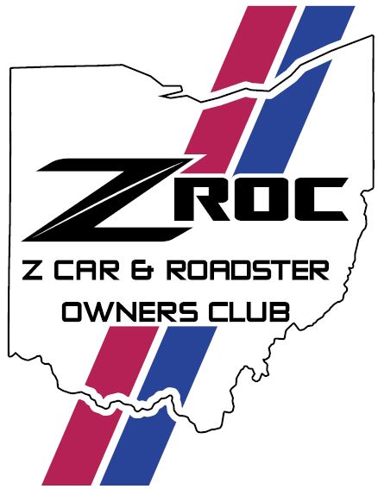
ZROC Quarterly newsletter
NOVEMBER 2025 issue# 5
BOARD
President – Lee Bivens, VP – Shelby Wofford, VP Membership – Shane Bradfield, VP Communications – Brian Bivens, VP Finance – Ernie Lawson, VP Dealer Relations – Tom Marshall, Member at Large – Scottie Wappenstein

Early Holiday Greetings,
Well, the end of another driving season is upon us, at least for those of us here in the Mid-West. If you have the inclination, please consider serving YOUR club by either serving in a board position or helping by planning an event for the club in 2026. We are always looking for new people and ideas to keep things fresh. Contact any of the board members if you would be interested in helping out. We will also be taking nominations at our end of the year meeting this month. Hoping your Holidays are cheerful and Merry and that 2026 is a GREAT YEAR!
Enjoy and HAPPY READING & HOPE TO Z YOU AT THE NEXT CLUB EVENT!!

Previous Events
JULY
ZROC Happy Hour – The club bought pizza and several club members gathered together to have some adult beverages, chat and share comradery.
Arthritis Foundation Car Show – The 42nd annual event drew a number of the ZROC crew out to show off their rides and wander through the field of hundreds of other vintage vehicles

AUGUST
Dayton Cars & Coffee – Some of the club members gathered to make the early morning drive to Dayton for this event. It’s a very large event and if you get a chance to go in 2026 you should check it out.
Nissan North Grand Opening and Cars & Coffee Event – One of our long-time dealerships opened a new showroom/building and ZROC was invited to attend. Many thanks to Tyler Baird for including ZROC in these events.
Z’s Across America Rallye – ZROC joined with ZCCC to lead the 6th segment of this cross-country drive (this segment started in York, PA and ended in Indianapolis, IN) it was a great drive (except for the construction traffic on I-70 in Indiana). The next morning the ZROC crew who spent the night in Indy got up and toured the Indy 500 museum located on the track. It was pretty cool.
Fundraiser Car Show for Watkins Memorial HS – A group of ZROC entered in this fund-raising event, some folks even got a trophy!

SEPTEMBER
555 Drive – An always popular drive the club had a good turnout for this one, as usual. Ended the drive with lunch at Papa Boo’s on Buckeye Lake.
ZCON – Club members Bruce and Suzanne Phillippi made the drive to Nashville, TN to attend the event and see the unveiling of the limited edition Midnight Purple Z.

OCTOBER
Hocking Hills Drive – Another always popular drive. The club had a good turn out for this event and drove some great twisty roads in the Hocking Hills area. Changed it up a bit and had a picnic lunch and Rock House state park before drive back home.

Upcoming Events
November – End of Year Meeting
December – ZROC Christmas Party
January – Annual Meeting

IN MEMORY
One of our founding club members has passed away. Patty (Pat) Tarkin-Eggleston, was our club treasurer for over 10 years. She and her husband, Gregg, were very active in the club for many years. We extend our condolences to Gregg and Patty’s family.

RAN WHEN PARKED
As part of the grand opening event for Nissan North’s new facility they asked ZROC’s own Andy Doll to display his 240Z race car in the showroom for about 5 or 6 weeks. It was very, very cool!!

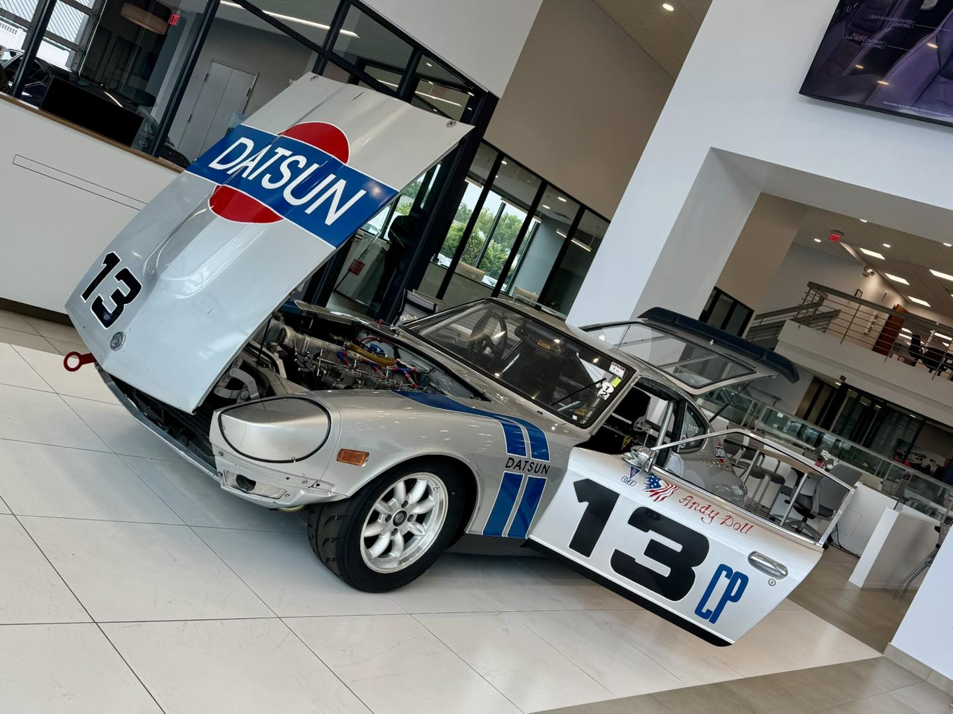

Please be sure to contact any of the board members with any questions or suggestions. Members can always stay up to date on upcoming and previous club events (and see pictures of the events) by liking and following ZROC on our Facebook Page or by visiting the club web page at www.zrooc.org

